**Westminster United Church Concert**

Please join us for an evening of music and storytelling,

featuring the musicians and authors of Westminster United Church

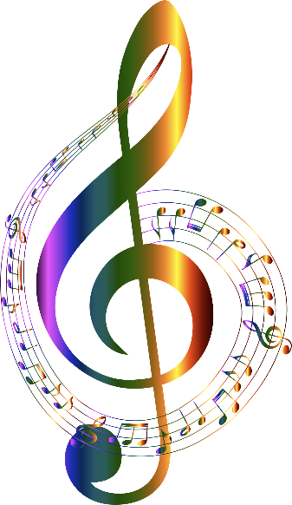

Location: Westminster United Church, Humboldt

703 – 13 Avenue

Church Sanctuary

Time: Saturday, November 8th, 7:00pm

Silver Collection fund raising for web-internet cameras and hardware

Featured Artists

Ian Elliott, Dale Avison, Tanner Hall, Maxine Moore, Carol Gossner, Michelle Peltier, Dave Tomchyshen, Michele Ackerman, Kevin Ackerman and others

Coffee & snacks during intermission