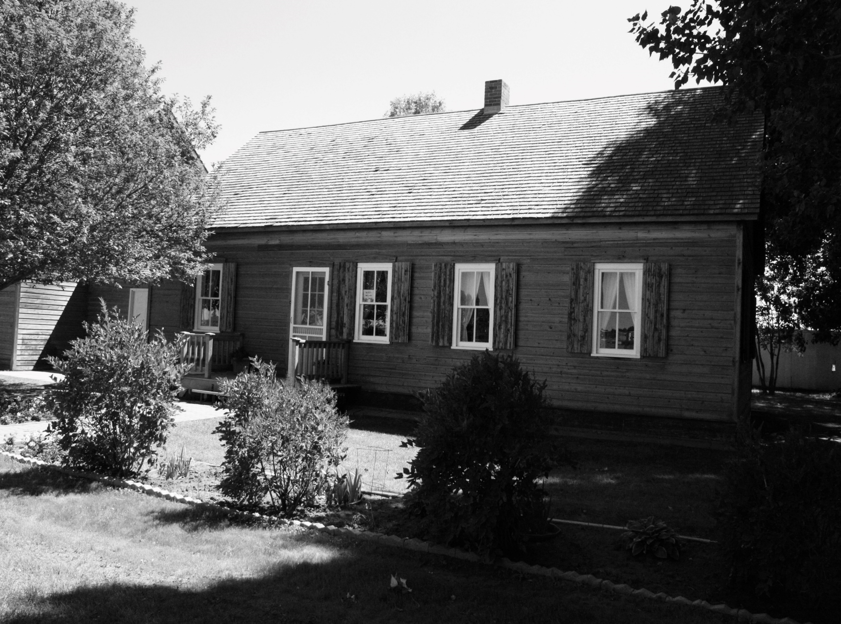
Raise the Roof

Fundraiser Concert & Silent Auction
For the Mennonite Heritage Village

Friday, November 14, 7:00 pm; Eastside Church of God

Music by Five Guys

Auction items include:
- Gift certificate from Treens | - Sausage package from Valley Meats
- Jean blanket made by Mary B. | - Plus many more items!

Dessert will be served

$10/person
Tickets available at Pharmasave or contact Elaine Schapansky at 306-741-9012

