For Immediate Release

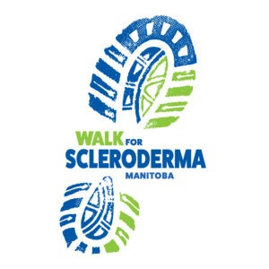
Annual Scleroderma Manitoba Fundraising Walk

“June is Scleroderma awareness month, and we are inviting Manitobans from across the province to show their support by joining our Walk for Scleroderma to raise awareness and critical dollars for research and patient support,” says Jo-Ann Lapointe McKenzie, president of Scleroderma Manitoba.

The Annual Walk for Scleroderma is scheduled for June 2022. This year, after two years of the Covid-19 pandemic, we will host an in-person event on June 26, 2022 in St. Vital park, provided Public Health Restrictions allow. There are many who are immunocompromised and are reluctant to gather in large groups so there is the option to walk in your community over the month of June. Participants can walk, run, or ride for scleroderma every or any day in June. Lapointe McKenzie says the goal this year is to achieve a total 2470 kilometers collectively by all participants. This is the distance from Leaf Rapids to Steinbach. “We encourage friends, family and supporters of scleroderma patients, and in fact, all Manitobans to show their support, and register to participate, or make a donation.” Interested participants can register or donate at sclerodermamanitoba.com.

Scleroderma is a rare disease affecting hundreds of Manitobans and their families. Scleroderma is an auto-immune disease in which the immune system goes awry. Too much collagen, or scar tissue, is produced by the body which results in damage to blood vessels, causing fibrosis in joints and internal organs. Scleroderma can be fatal. It is a difficult disease to diagnose, and often people wait for some time before they get an explanation for their symptoms. There is presently no cure.

Scleroderma Manitoba, a non-profit charitable organization, helps to connect this community and fight feelings of fear and isolation that come along with a rare disease.

For more information contact:
Jo-Ann Lapointe McKenzie, President
Scleroderma Manitoba
204 510-2855
sclerodermamb@gmail.com
www. sclerodermamanitoba.com

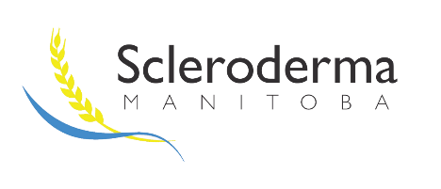
Scleroderma Backgrounder

What is scleroderma?
Scleroderma (systemic sclerosis or SSc) is a largely misunderstood chronic disease affecting about approximately 22,000 Canadians. Scleroderma affects five to six times more women than men. A recent study by the University of Manitoba found the incidence of scleroderma in Manitoba to be between 246 and 261 cases per 1 million people, which is comparable to other estimates in North America. Researchers estimate there are about 330 scleroderma patients in Manitoba; prevalence is higher in Northern Manitoba.
This disease is derived from the Greek words “skleros” (hard) and “derma” (skin) and is characterized by progressive skin hardening.
Scleroderma is an autoimmune disease, a condition in which a person’s immune system turns against itself by producing antibodies that attack its own tissues. It is characterized by an overproduction of collagen and damage to the blood vessels that can cause scarring within various organs including the lungs, kidneys and digestive systems. This imbalance leads to a hardening of the skin (fibrosis) and an alteration of the affected organs. Moreover, in most cases, scleroderma limits the motor skills and dexterity of those affected and can cause great physical and psychological suffering since it produces significant appearance-related changes. Fatigue is a common symptom.
In most cases, scleroderma patients have difficulty with coordinating small movements of the hands and fingers. For example, patients may have trouble doing up buttons and writing. Finger ulcers are a common problem which causes pain, and in severe cases, can lead to amputation.
Facts about Scleroderma:
- Scleroderma is found throughout the world. It is estimated that 2.7 million worldwide have scleroderma.
- Scleroderma is 5 to 6 times more common in women than men.
- The disease is most commonly diagnosed between ages 30-50, but it can also strike children and people of all age groups. A recent study found the mean age of diagnosis in Manitoba was 49.
- Scleroderma is not contagious.
- Both limited and diffuse scleroderma are associated with a significant reduction in life expectancy. For people who have mostly skin involvement and no major organs involved, the long-term outlook is more favourable.
- It is still unknown what exactly causes this autoimmune disease.
- Since each case is unique, no two patients will follow the same course of the disease.

About Scleroderma Manitoba

Scleroderma Manitoba, founded in 1993, is an all-volunteer, registered charity created to support scleroderma patients, their families, caregivers, and supporters.
Our Mission
To enrich the lives of those touched by scleroderma in Manitoba.

Scleroderma Manitoba focuses on providing support for those living with scleroderma, building connections within the scleroderma community, raising awareness, fundraising, and patient advocacy.

Each year, Scleroderma Manitoba directs a significant proportion of the funds it raises to research projects for scleroderma treatments. Recently, this has included contributions to the Scleroderma Patient Intervention Network (SPIN) which researches and develops programming for scleroderma patients and their families and caregivers.

Visit our website: www.sclerodermamanitoba.com

Follow us on Twitter: @MBScleroderma

Facebook: facebook.com/sclerodermamanitoba

Email: sclerodermamb@gmail.com

Phone: 204 510 2855
Scleroderma Manitoba
16 Carlington Crescent
Oak Bluff, MB
R4G 0C5

