TENT MEETINGS
Everyone Welcome
AUGUST 19-21
Friday 7:30 pm
Saturday 6:30 pm
Sunday 10:30 am & 6:30 pm
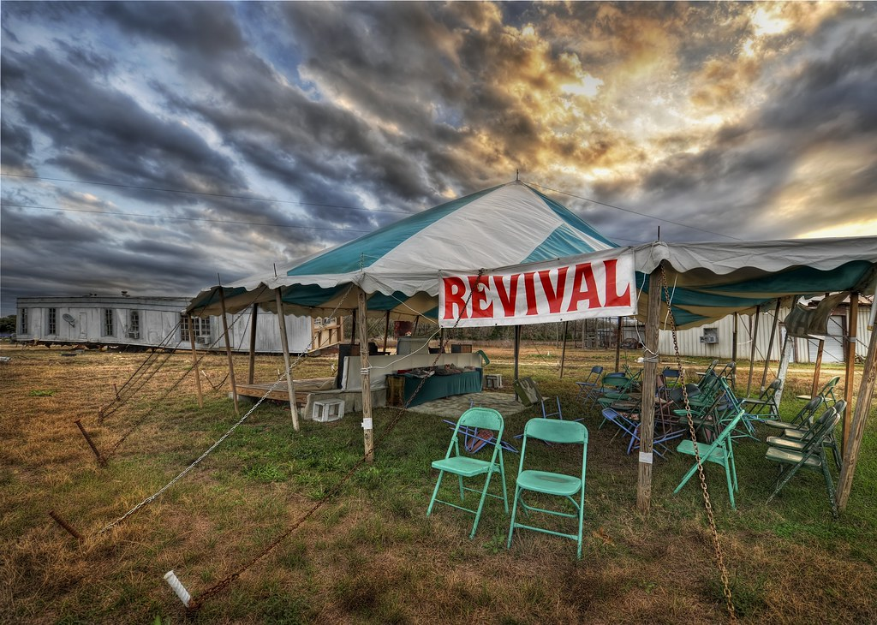
This Photo by Unknown Author is licensed under CC BY-SA-NC
20 MINUTES SOUTH OF WINNIPEG
Gleanlea,MB on the 75 Hiway S.

FOR MORE INFORMATION and DIRECTIONS
INFO@DLCHURCH.CA WWW.DAILYLIFECHURCH.CA

DAILY LIFE CHURCH
Is Hosting Tent Meetings Aug. 19-21
Friday Aug. 19th 7:30pm
Saturday Aug. 20th 6:30pm
Sunday Aug. 21st 10:30am & 6:30pm
Free BBQ after the Sunday Morning Service
Special Speakers from our Remnant Leaders Network
Everyone is Welcome / Bring Your Lawn Chairs
2304 Andrechuk Road, Glenlea, MB

